Department of Treasury Request for Proposal Response

Solicitation # 2032H323R00065

On-Demand Executive Coaching with Assessments &

Leadership Development Resources

Volume III: Management Approach

Submitted By:

Company Name: **Sagely, LLC**

Address: **320 South Main Street Providence, RI**

DUNS: **075888104**

Point of Contact: Mandy Graham

Phone Number: 781.626.2797

Email: [mandy@growsagely.com](mailto:mandy@growsagely.com)

SUBMITTED TO:

Mr. Aaron C. Hill & Ms. Angela Gallo

5000 ELLIN ROAD

Lanham MD 20706

**August 31, 2023**

*This response includes data that must not be disclosed outside the Government and must not be duplicated, used or disclosed in whole or in part for any purposes other than to evaluate this response. If, however a contract is awarded to this Offer as a result of or in connection with the submission of this data the Government must have the right to duplicate use or disclose data to the extent provided in the resulting contract. This restriction does not limit the Government’s right to use information contained in this data if it’s obtained from another source without restriction. The data subject to this restriction is contained in this response.*

## 

# Table of Contents

**Table of Contents 2**

**Glossary of Abbreviations 3**

1.0 Management Plan 4

1.1 Contract Project Management 4

1.2 Task Ordering Process 4

1.3 Customer Support 4

1.4 Monthly & Quarterly Status Reports (SOW 4.1) 4

1.5 Final Reports (SOW 4.2) 6

1.6 508 Compliance 6

2.0 Subcontracting Plan 6

# 

# Glossary of Abbreviations

| **Acronym / Abbreviation** | **Definition** |
| --- | --- |
| CPM | Contract Project Manager |
| COR | Contracting Officer Representative |
| FFP | Firm Fixed Price |
| GPM | Government Program Manager |
| ICF | International Coach Federation |
| IDIQ | Indefinite Delivery/Indefinite Quantity |
| OPM | U.S. Office of Personnel Management |
| PM | Project Management |
| RFP | Request for Proposal |
| ROI | Return on Investment |
| SOW | Statement of Work |
| TEI | Treasury Executive Institute |

# 

# 1.0 Management Plan

### 1.1 Contract Project Management

Ms. Mandy Graham is our dedicated Contract Project Manager (CPM) for this requirement:

Email: [mandy@growsagely.com](mailto:mandy@growsagely.com)

Address: 320 S Main Street Providence, RI, 02903

Phone: 781.626.2797

Response times are less than four (4) business hours, and in the event of the CPM being unavailable, the Alternate Designated Representative is Tory Cuff ([tory@growsagely.com](mailto:tory@growsagely.com)) to mitigate any bottlenecks and ensure responsiveness.

### 1.2 Task Ordering Process

All task orders are **Firm-Fixed Price (FFP)**. Each license provides the Government access to the Sagely Platform via online subscription service with individual log-in 24 hours a day, seven (7) days a week. Individual licenses are **provided as a 12-month subscription**. At the request of the Government, Sagely will allow for individual licenses to be transferred **as long as more than four (4) months remain** on the license.

Sagely seeks a 30-day advance notice for the implementation of new Task Orders (TO). However, the Sagely Team possesses the capability to accelerate this process to a 2-week timeframe, effectively aligning with the Government's urgent demands in instances of quick-turn requirements. Upon contract award, Ms. Graham works with the Government Contracting Team to formalize the TO process guide for TEI and its partners. 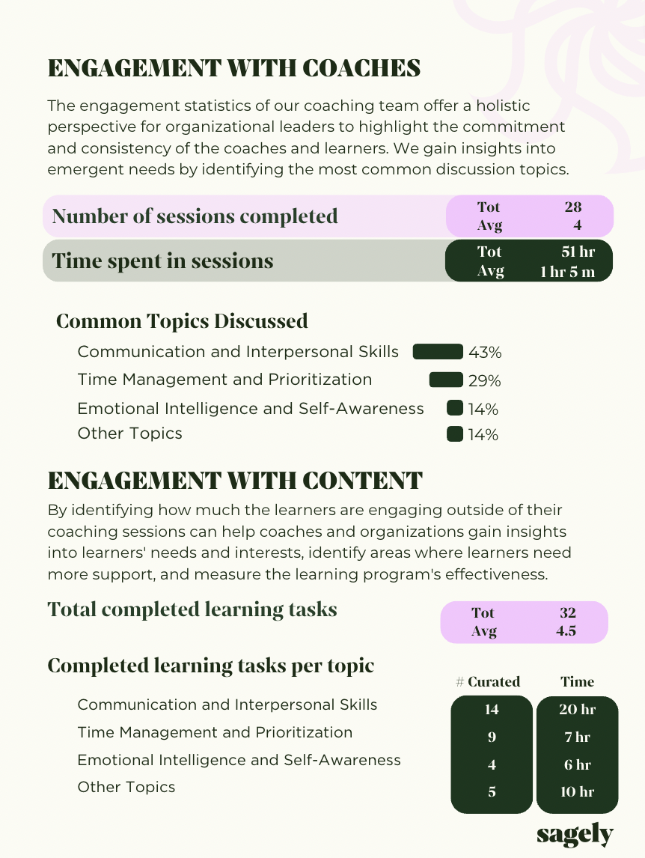

### 1.3 Customer Support

The Sagely platform is available for normal operation 24 hours a day, 7 days a week. Customer Support is available via email at support@growsagely.com during normal business hours, with a response time of **1 business day or less** for all issues.

### 1.4 Monthly & Quarterly Status Reports (SOW 4.1)

The metrics outlined in SOW 4.1.1 and 4.1.2 are all accessible within the Sagely platform and compiled in monthly reports. Reporting takes place through three main mechanisms: firstly, directly within the Sagely platform utilizing the administrative dashboard; secondly, through monthly reports sent via email to Government Stakeholders; and thirdly, by providing access to a secure URL for stakeholders, granting them the ability to view both the current and previous monthly reports. A sample report is shown above. The monthly report includes all the data as outlined in SOW 4.1.1, 4.1.2, 4.1.3, and 4.1.4.

In addition to contract Return on Investment (ROI), we place a strong emphasis on the individual’s development progress ROI. The Sagely Platform also gives businesses insight into the skills of their organization via an executive (administrative) dashboard. **Our dashboard provides real-time metrics and insights that enable organizations to understand their workforce-** learning habits, educational interests, and skill levels- to tailor specific learning opportunities and keep employees engaged and growing professionally.

Quarterly Customer Satisfaction Surveys are used in our engagements to measure growth, impact, value, and engagement levels. On a monthly basis, learners and coaches on the platform are prompted to provide quick feedback on their coaching relationship and on the use of the platform. Additionally, our CPM, Ms. Graham, sends our quarterly customer satisfaction survey results to Government Stakeholders, including the Government Program Manager (GPM) and COR, **to showcase key satisfaction data**. This feedback is available on-demand within the administrative dashboard and included in monthly status reports.

The surveys are tailored but at minimum, cover three areas outlined in SOW (4.1.3):

* Percentage of learners that feel coaching is a valuable use of their time
* Percentage of learners that feel coaching makes them more effective at work
* Percentage of learners that feel they have made meaningful progress toward their goals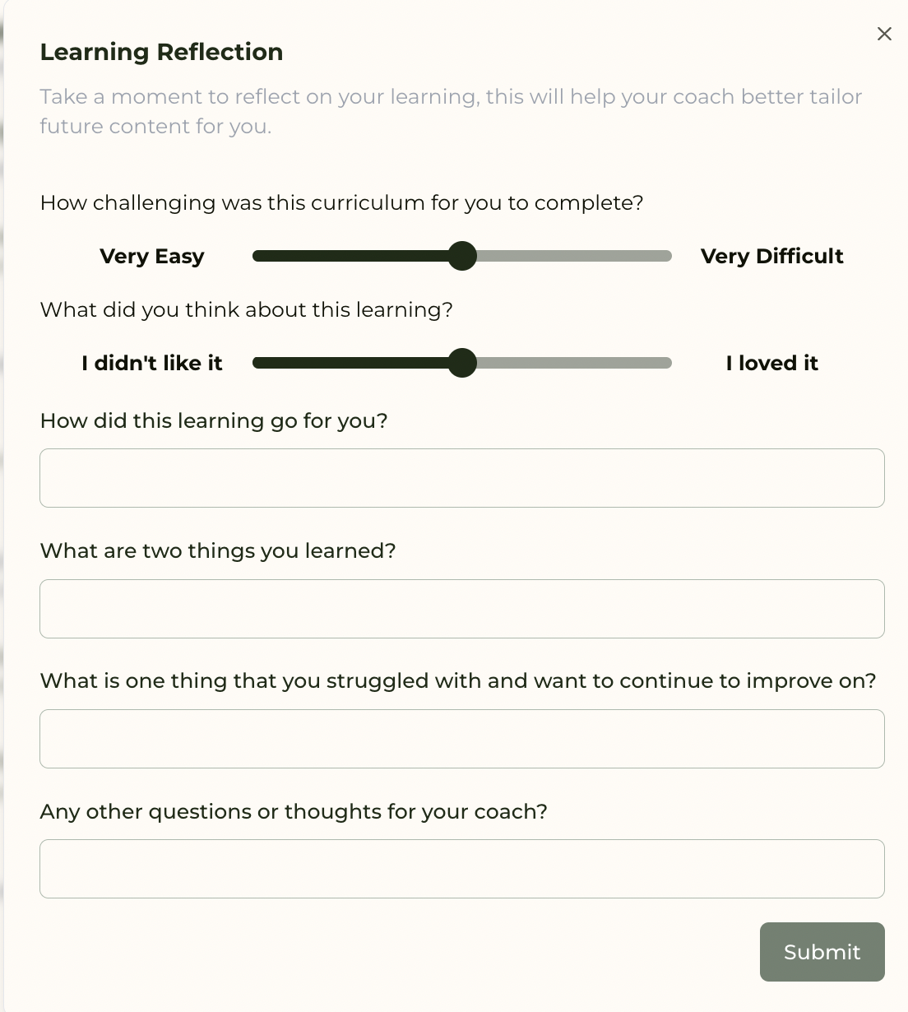

In addition to the specific information requested by Treasury above, our quarterly customer satisfaction surveys also collects data through questions like these:

* Compared to when you started this coaching engagement, how confident do you feel in your current role?
* Do you feel that your coach is a good match for your learning style and goals?
* What topics have resonated with you the most?

Apart from our Quarterly Customer Satisfaction Surveys, each curriculum ends with a Learning Reflection, where the learner provides feedback on individual topics.

Sagely provides multiple mechanisms for feedback loops, including Learning Reflections on specific curricula, Coaching Feedback on the coach/coachee relationship, and quarterly customer satisfaction surveys with all stakeholders.

### 1.5 Final Reports (SOW 4.2)

On top of our monthly reports, our Final Report covers all the metrics requested in SOW 4.2, regarding coaching engagement, learning resources outside of coaching sessions, post-session feedback, and behavioral change. This is made efficient by the backend data we pull from our Sagely Platform.

**Our team is well-equipped to support all PM/COR communications to ensure effective execution and management of the contract performance, timely execution of the contract deliverables, and minimize performance risk**.

### 1.6 508 Compliance

Sagely affirms its **adherence to all Section 508 Accessibility Standards** pertinent to this requirement. We are committed to guaranteeing the compatibility of all provided services with Section 508 guidelines and to ensuring all outputs and software delivered by Sagely are fully compliant with Section 508 accessibility requirements.

## 2.0 Subcontracting Plan

In accordance with the requirements outlined in SOW 2.4.3, Sagely, a Veteran-owned small business, is committed to delivering exceptional results by effectively managing all tasks described in the SOW. While we are not required to submit a detailed 52.219-9 subcontracting plan as a small business, we acknowledge the importance of transparency and, by Government request, will provide a breakdown of our internal allocations and any 1099 agreements for supplemented expertise that is needed at scale.

Our team comprises highly skilled professionals with extensive experience in the relevant domains. Given our internal capabilities and expertise, we will perform all required tasks in-house without the need for subcontracting. The Sagely team has relationships with a vast network of ICF coaches. We work with the University of San Diego, Carnegie Mellon, MIT, and the University of Southern Maine. This approach enables us to maintain direct control over project execution, ensuring timely delivery, quality, and accountability. The Sagely Platform is a critical enabler for scale, allowing the ability to quickly onboard both clients and ICF-certified coaches to meet the needs of the Government.